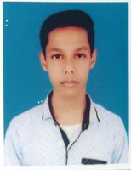

**EDUCATION**

**PROFILE**

CURICULUM VITAE

**Manidwiptam Halder**

* I complete my madhyamik exam from Kalyani Univercity Experimantal High School in 2020.

I lived in Kalyani, Natunpally Ward-04.My father name is Hareram Halder.Now I am doing Electrical Engineering from Ranaghat Govt. Polytechnic College 1st year 2nd sem.

**CONTACT**

**SKILLS**

Ph:- 7439572883

Email:- manidwiptamhalder@gmail.com

* I am good reader.
* I can do anything in team work.

**HOBBIES**

  